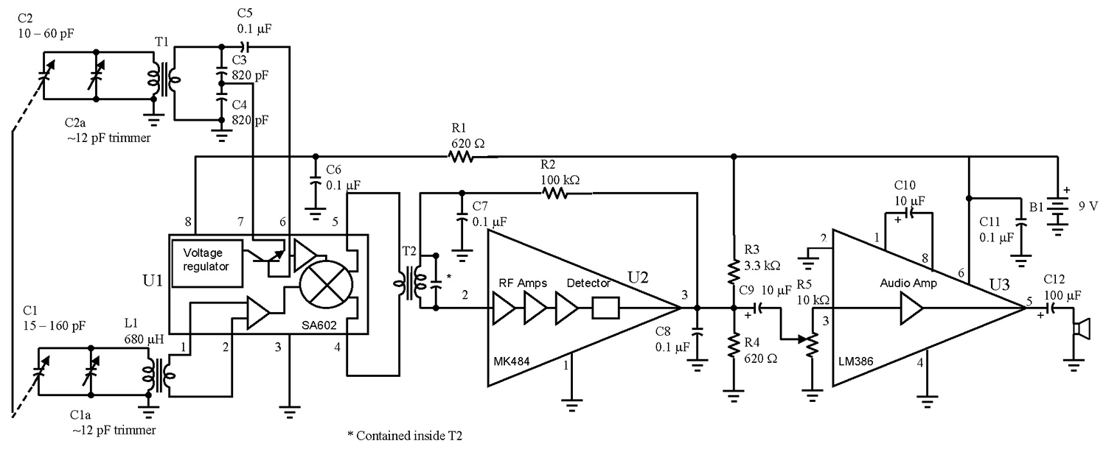
http://www.nutsvolts.com/magazine/article/a_simple_superhet

